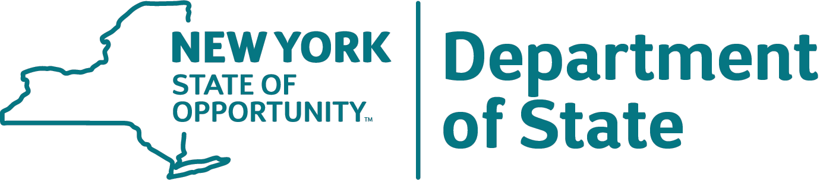

Funding for this project provided by an
Environmental Protection Fund

Local Waterfront Revitalization Program Grant
(Project Name)
(Recipient Municipality)
Kathy Hochul, Governor Robert J. Rodriguez, Secretary of State
(Local Official/Municipal Executive)

