CONTACT COVER PAGE
RFA #20-ONA-30

Submit as Attachment 1

Application for Part A or Part B:

For Part B - Region Applying For:

Applicant (Organization) Name:

Executive Director:

Application Point of Contact:

Point of Contact Phone:

Point of Contact E-mail:

Executive Address:

REGIONAL IDENTIFICATION SHEET (Page 1 of 2)

For Part B: Submit as Attachment 2

Through the award available under the NYS Professional Pathways for High-Skilled Immigrants RFA #20-ONA-30 Applicant ________________________ (Insert Organization Name on the line) proposes to host and support an ONA Job Coach capable of providing the services outlined in this RFA in the following region (select ONLY region):
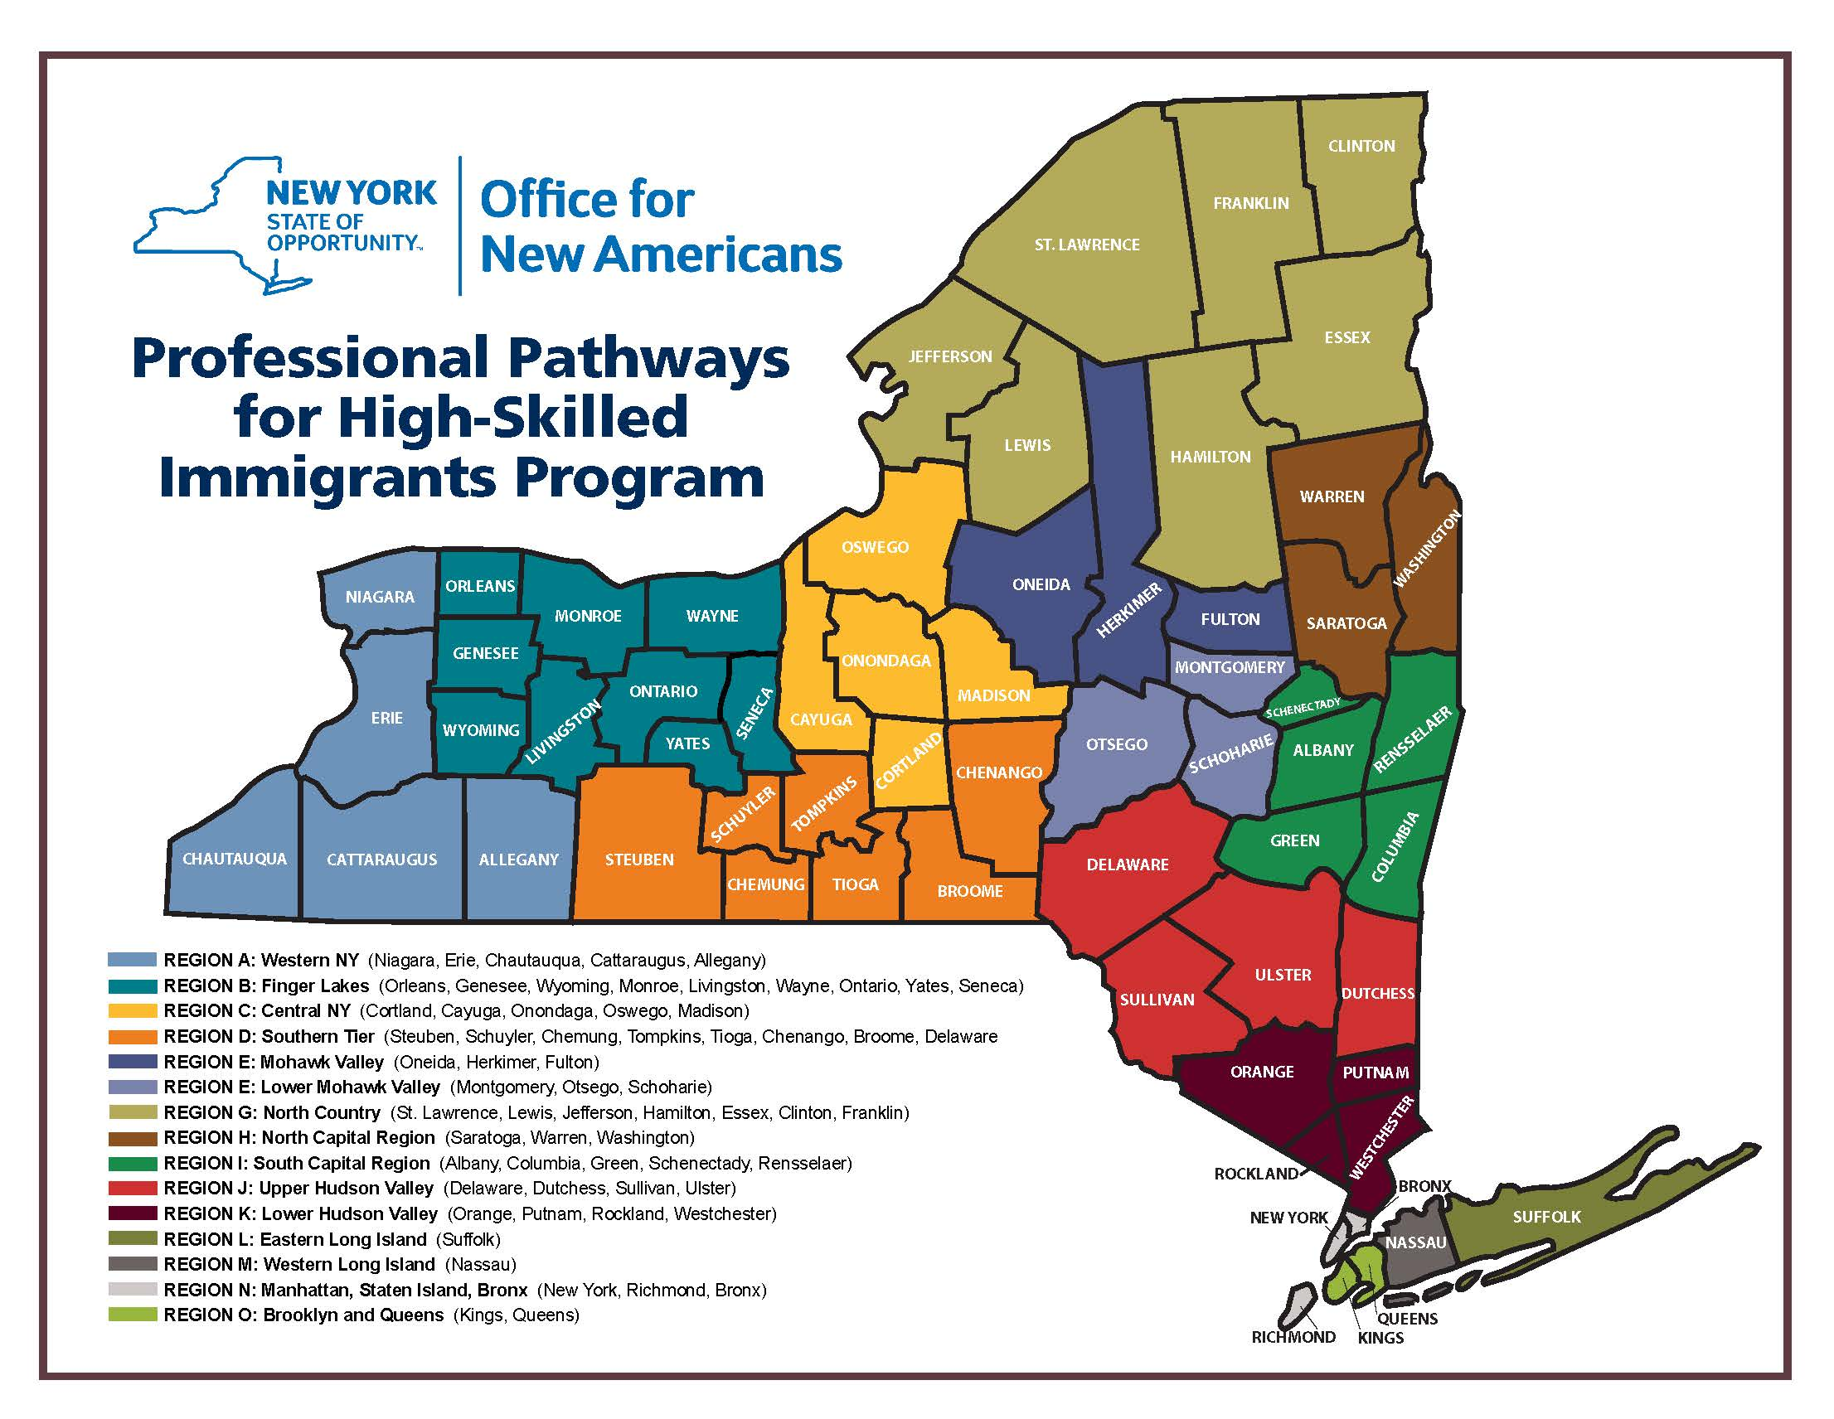

REGIONAL IDENTIFICATION SHEET (Page 2 of 2)
RFA #20-ONA-30

For Part B: Submit as Attachment 2

Applicant Name: _____________________________________________________________

REGION SERVICE AREA SELECT ONE

A Western NY (Niagara, Erie, Chautauqua, Cattaraugus, Allegany) □
B Finger Lakes (Orleans, Genesee, Wyoming, Monroe, Livingston,
Wayne, Ontario, Yates, Seneca) □
C Central NY (Cortland, Cayuga, Onondaga, Oswego, Madison) □
D Southern Tier (Steuben, Schuyler, Chemung, Tompkins, Tioga,
Chenango, Broome, Delaware) □
E Upper Mohawk Valley (Oneida, Herkimer, Fulton) □
F Lower Mohawk Valley (Montgomery, Otsego, Schoharie) □
G North Country (St. Lawrence, Lewis, Jefferson, Hamilton, Essex,
Clinton, Franklin) □
H North Capital Region (Saratoga, Warren, Washington) □
I South Capital Region (Albany, Columbia, Green, Schenectady,
Rensselaer) □
J Upper Hudson Valley (Delaware, Dutchess, Sullivan, Ulster) □
K Lower Hudson Valley (Orange, Putnam, Rockland, Westchester) □
L Eastern Long Island (Suffolk) □
M Western Long Island (Nassau) □
N Manhattan, Staten Island, Bronx (New York, Richmond, Bronx) □
O Brooklyn and Queens (Kings, Queens) □

NEW YORK STATE DEPARTMENT OF STATE
New York State Office for New Americans
Budget Summary – RFA #20-ONA-30

For Part A: Submit as Attachment 8
For Part B: Submit as Attachment 9

Applicant:_____________________________________________

Budget Period: to

Cost Categories |  | Total Project Cost by Category (dollar value):
1. | Personnel Services
2. | Fringe
3. | Travel
4. | Advertising & Printing
5. | Non-Personnel Cost
6. | Administrative Cost Rate ( ___ %)
TOTAL PROJECT COST

Personnel Services
Title | Annual Salary | (%) | Total
Justification: Completely justify all positions. Describe duties and contributions to the project. Include a brief description of duties/responsibilities for each position.

Personnel Services Total (dollar value):

Fringe
Describe and justify each fringe cost in detail, including fringe rate, and what is included as part of fringe benefits.
Fringe Total (dollar value):

Travel
Describe and justify all travel in detail, including cost per item. Justify the need for travel and how it will benefit the project.
Travel Total (dollar value):

Advertising & Printing
Describe and justify all printing and advertising costs in detail, including cost per item. Justify the need for printing and advertising, and how it will benefit the project.
Advertising & Printing Total (dollar value):

Non-personnel Services
Describe and justify all non-personnel services in detail, including cost per item. Justify the need for these non-personnel services, and how they will benefit the project.
Non-personnel Services Total (dollar value):

Administrative Cost Rate
Describe administrative cost rate to be applied to the grant. Specify whether the rate will be federally approved indirect cost rate, 10% de minimis rate, agency determined direct allocation methodology. Include the categories to which the rate will be applied.
Administrative Cost Rate (dollar value):

NYS DEPARTMENT OF STATE
MWBE COMPLIANCE FORM – Submit as Attachment 3

DEPARTMENT OF STATE (DOS) - MINORITY AND WOMEN-OWNED BUSINESS ENTERPRISES (MWBE) PROGRAM
Article 15-A of the NYS Executive law was enacted on July 19, 1988, to promote equality of economic opportunities for MWBEs and to eliminate barriers to their participation in state contracting.

The contract’s specific MWBE goals can be identified in the RFP, RFA and/or the budget page in applicable contracts. All applicable contracts, including contracts supported with federal funding which do not have a DBE component, are assessed for MWBE goals.

- Personal services (i.e. payments to staff for labor), staff benefits, training  - Travel reimbursements | - Utilities, postage, telephones  - Sole source contracts  - Operating transfers | - Certain rentals and repairs  - Unemployment insurance and tuition reimbursement

For grants, certain items are exempted from the goal calculation. These include:

Note: The portion of matching fund/local share is not included in the goal calculation.

Your responsibilities under Article 15-A are:
- To Make Good Faith Efforts (GFE)

You will be required to make “GFE” to provide meaningful participation to MWBEs as subcontractors or suppliers in the performance of contracts.

Documentation of GFE includes, but is not limited to (5 NYCRR §142.8):
- Evidence of outreach to MWBEs: mail, email, phone calls and follow up;
- Written responses by MWBEs to the grantee/vendor’s outreach;
- Copies of search(es) of the directory and advertisements for participation by MWBEs in appropriate general circulation, trade, and minority or women-oriented publications;
- Attendance at any pre-bid, pre-award, or other meetings, if any, scheduled by the grantee with MWBEs including dates and location;
- Information describing specific steps undertaken to reasonably structure the contract scope of work to maximize opportunities for MWBE participation; and
- Information describing non-MWBE subcontractors’ efforts to engage MWBEs to undertake part of the project’s work or to procure equipment/ materials/supplies.

2. Required MWBE Reporting for Contracts with Utilization Goals

Within ten days of receipt of the award notification from DOS, submit:
- Form A
- Form B (for contracts > $250,000)
- Form D or D-1.

For non-federally funded contracts, once the contract is executed, set up an account in the New York State Contract System (system) to:
- Submit MWBE utilization plan (if required)
- Report MWBE utilization
- Track and monitor transaction on the contract.

Throughout the contract term:
- Report MWBE utilization through the system OR submit Form F - Quarterly MWBE Utilization

Waiver Request – Form E can be submitted if there are no opportunities for MWBE participation, or to demonstrate the GFE to meet the contractual goals.

Only the use of New York State-certified MWBEs will count towards meeting NYS contract goals:
- The NYS MWBE Directory is located at: https://ny.newnycontracts.com/FrontEnd/VendorSearchPublic.asp

By signing, the applicant confirms that they understand the MWBE requirement, as summarized above, and agree to show due-diligence and to make good faith efforts to provide meaningful participation by MWBEs, whenever possible, if awarded the contract.
Signature: |  | Date:
Printed Name |  | Title

