APPENDIX A: APPLICATION FORM

General Information
Name of Applicant (Full legal name of corporation/agency)
(Enter text here)
Applicant Mailing Address (Full legal address of corporation/agency)
Street | (Enter text here)
City | (Enter text here) | NY | Zip | (Enter text here)

Name of Executive Director/Chief Executive Officer |  |  |  | (Enter text here)
Title | (Enter text here)
E-mail Address |  | (Enter text here)
Telephone |  | (Enter text here) | Fax |  | (Enter text here)

Name of Project (if applicable) | (Enter text here)
Location (Geographic Area) of Project: | (Enter text here)
Designated Community in which CBO may provide services: |  | (Enter text here)

Total Funds Requested, $ | (Enter text here)

Name of Board of Directors Chair/President: |  |  | (Enter text here)
Title | (Enter text here)
Street | (Enter text here)
City | (Enter text here) |  |  | NY | Zip |  | (Enter text here)
E-mail Address |  | (Enter text here)
Telephone |  | (Enter text here) |  | Fax |  | (Enter text here)

B. APPLICANT CERTIFICATIONS, ATTESTATIONS AND ACKNOWLDGEMENTS
Applicant is a 501(c)(3): | YES NO
Year of New York State Incorporation:
Applicant Federal Employer Identification Number:
Applicant Charities Registration Number:
Applicant New York State Vendor ID Number:
Applicant DUNS or SAM.gov Unique Entity ID Number:
Applicant has operated as a CBO continuously for 5 years: | YES NO
Applicant certifies that it currently provides direct services to low-income individuals: | YES NO
Applicant certifies that it will serve a population that meets the maximum allowable percentage of Federal poverty income guidelines (currently 200% for Federal Fiscal Year 2023): | YES NO
Applicant certifies it is incorporated for the purposes of providing services or other assistance to economically or socially disadvantaged persons within its designated community. | YES NO
Applicant certifies more than half of its board of directors resides in its designated community. | YES NO
Board of Directors List with address of residences is attached: | YES NO
Certificate of Incorporation is attached: | YES NO
Vendor Responsibility Acknowledgement: I hereby acknowledge that if awarded funding, we will comply with the Vendor Responsibility requirements of the State of New York. | YES NO
By submission of this application, each applicant and each person signing on behalf of any applicant certifies, and in the case of a joint application each party thereto certified as to its own organization, under penalty of perjury, that the applicant has and has implemented a written policy addressing sexual harassment prevention in the workplan and provides annual sexual harassment prevention training to all of its employees and the policy, at a minimum, meets the requirements of Labor Law § 201-g. | YES NO
By submission of this application, each applicant and each person signing on behalf of any applicant certifies, and in the case of a joint application each party thereto certifies as to its own organization, under penalty of perjury that to the best of their knowledge and belief that (1) the prices in this application have been arrived at independently without collusion, consultation, communication, or agreement, for the purpose of restricting competition, as to any matter relating to such prices with any other applicant or with any competition, (2) unless otherwise required by law, the prices which have been quoted in this application have not been knowingly disclosed by the applicant and will not knowingly be disclosed by the applicant prior to opening, directly or indirectly, to any other applicant or to any competitor and (3) no attempt has been made or will be made by the applicant to induce any other person, partnership, or corporation to submit or not to submit an application for the purpose of restricting competition. | YES NO
Applicant certifies that any resulting contract may be cancelled for the applicant’s refusal to testify under the circumstances set forth in State Finance Law § 139-a. | YES NO
Applicant certifies it is not nor shall it participate in a boycott in violation of State Finance Law § 139-h. | YES NO
Applicant has attached the completed certification under Executive Order No .16 regarding business conducted in Russia. | YES NO
Applicant is Prequalified on the NYS Grants Gateway. | YES NO

CERTIFICATION
The applicant certifies that the information in this application is correct and that CSBG funds will be used to provide services and activities benefitting low-income persons meeting the federal Poverty Guidelines, in accordance with the purposes, goals, and assurances of PL 105-285.
Print Name: |  | Signature: |  | Date:

PAGE LIMIT INFORMATION: An applicant’s total response to Sections C, D, and E should not exceed 9 pages total. Responses to the aggregate of Sections C, D and E that go beyond 9 pages, will not be read.

C. ORGANIZATION HISTORY AND EXPERIENCE

Provide a summary describing the following:
Describe the financial literacy training and education that the organization currently provides or has experience providing to low-income individuals and families as defined by the Federal Poverty Guidelines showing at least five years of experience.
.

(Enter text here)

Describe the organization’s accomplishments of their past and/or present programming providing financial literacy training and education to low-income individuals and families.

(Enter text here)

Describe the current staffing and how the experience of the staff lends itself to the success of the organization’s past and present programming providing financial literacy training and education to low-income individuals and families. Provide an organizational chart and the resume of your Executive Director as part of “Attachment E: Organizational Documents.”

(Enter text here)

D. ORGANIZATION CAPACITY

Describe plans to staff new programming or supplement existing programming in order to provide financial literacy training and education services to low-income individuals and families as defined by this RFA.

(Enter text here)

Describe how new programming or supplementation of programming targeting low-income individuals and families will align with overall organizational mission goals, and outcomes.

(Enter text here)

Describe applicants’ capacity to work with non-English proficient clients, including experience using interpreters and professional translation services.
(Enter text here)

E. PROPOSAL NARRATIVE

Describe the financial literacy and educational services that will be provided, to a minimum of 30 eligible households per year.

(Enter text here)

Describe how low-income individuals and families will be determined eligible to participate in the programs, services, and/or activities

(Enter text here)

Describe the programs, services and/or activities that will address the financial needs of the eligible low-income individuals and families. Proposals must include whether the programs, services and or/activities are new or expanding an existing program.
(Enter text here)

Describe how the organization plans to staff the programs, services and/ or activities proposed in their application, including whether the programs, services, and/or activities will require additional staff.

(Enter text here)

Describe how the funds will be used to develop linkages to bridge programs, services, and/or activities.

(Enter text here)

Identify how programs, services, and/or activities will be measured for results and/or outcomes.

(Enter text here)

F. PROGRAM WORKPLAN

Complete Appendix E “Work Plan” that includes a project timeline demonstrating how the programs, services, and/or activities will be executed, and how funds will be used over the course of the contract. Workplan must also include approximate dates for hiring, participant outreach, linkages that will support programming, and how the proposed programs, services, and/or activities will be evaluated.

G. BUDGET SUMMARY AND NARRATIVE

Complete Appendix D “Expenditure Based Budget” containing allowable, reasonable, allocable, and necessary costs.
Identify the use of one of the following: (a) indirect cost rate, (b) 10% de minimis rate, (c) direct allocation methodology, or (d) administrative rate. Please refer to Section IX in this RFA for specific requirements.

The budget must provide a detailed description, clearly linking cost to specific proposed programs, services, and/or activities. The narrative must clearly justify all costs proposed in the budget as they directly relate to project costs outlined in this RFA and must not include any ineligible costs as described in Section VIII of this RFA.

APPENDIX B
Submit as Attachment B: MWBE Compliance Form
NYS DEPARTMENT OF STATE (DOS) - MINORITY AND WOMEN-OWNED BUSINESS ENTERPRISES (MWBE) PROGRAM

Article 15-A of the NYS Executive law was enacted on July 19, 1988, to promote equality of economic opportunities for MWBEs and to eliminate barriers to their participation in state contracting.

The contract’s specific MWBE goals can be identified in the RFP, RFA and/or the budget page in applicable contracts. All applicable contracts, including contracts supported with federal funding which do not have a DBE component, are assessed for MWBE goals.

For grants, certain items are exempted from the goal calculation. These include:

- Personal services (i.e. payments to staff for labor), staff benefits, training  - Travel reimbursements | - Utilities, postage, telephones  - Sole source contracts  - Operating transfers | - Certain rentals and repairs  - Unemployment insurance and tuition reimbursement
Note: The portion of matching fund/local share is not included in the goal calculation.
Your responsibilities under Article 15-A are:
1. To Make Good Faith Efforts (GFE)  You will be required to make “GFE” to provide meaningful participation to MWBEs as subcontractors or suppliers in the performance of contracts.  Documentation of GFE includes, but is not limited to (5 NYCRR §142.8):  - Evidence of outreach to MWBEs: mail, email, phone calls and follow up;  - Written responses by MWBEs to the grantee/vendor’s outreach;  - Copies of search(es) of the directory and advertisements for participation by MWBEs in appropriate general circulation, trade, and minority or women-oriented publications;  - Attendance at any pre-bid, pre-award, or other meetings, if any, scheduled by the grantee with MWBEs including dates and location;  - Information describing specific steps undertaken to reasonably structure the contract scope of work to maximize opportunities for MWBE participation; and  - Information describing non-MWBE subcontractors’ efforts to engage MWBEs to undertake part of the project’s work or to procure equipment/ materials/supplies. | 2. Required MWBE Reporting for Contracts with Utilization Goals  Within ten days of receipt of the award notification from DOS, submit:  - Form A  - Form B (for contracts > $250,000)  - Form D or D-1.  For non-federally funded contracts, once the contract is executed, set up an account in the New York State Contract System (system) to:  - Submit MWBE utilization plan (if required)  - Report MWBE utilization  - Track and monitor transaction on the contract.  Throughout the contract term:  - Report MWBE utilization through the system OR submit Form F - Quarterly MWBE Utilization  Waiver Request – Form E can be submitted if there are no opportunities for MWBE participation, or to demonstrate the GFE to meet the contractual goals.

Only the use of New York State-certified MWBEs will count towards meeting NYS contract goals. The NYS MWBE Directory is located at: https://ny.newnycontracts.com/FrontEnd/VendorSearchPublic.asp.

By signing, the applicant confirms that they understand the MWBE requirement, as summarized above, and agree to show due-diligence and to make good faith efforts to provide meaningful participation by MWBEs, whenever possible, if awarded the contract.

Signature |  | Date
Printed Name |  | Title

vs. 12/10/2019

APPENDIX C
NYS Economic Regions Map

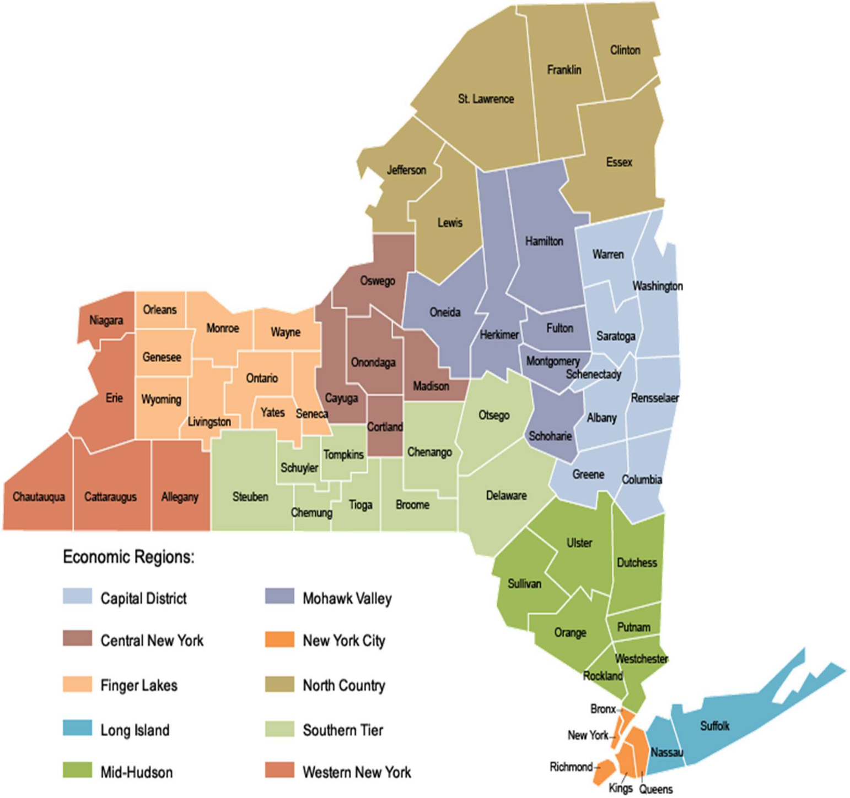

APPENDIX D
(Submit as Attachment C)
EXPENDITURE BASED BUDGET
SUMMARY

PROJECT NAME:
APPLICANT:

CONTRACT PERIOD: | From:
 | To:

CATEGORY OF EXPENSE | GRANT  FUNDS | TOTAL
1. Personal Services
a) Salary
b) Fringe
Subtotal
2. Non Personal Services
a) Contractual Services
b) Travel
c) Equipment
d) Space/Property & Utilities
e) Operating Expenses
f) Other
Subtotal
TOTAL

APPENDIX D
(Submit as Attachment C) - EXPENDITURE BASED BUDGET
PERSONAL SERVICES DETAIL

POSITION TITLE | ANNUAL  SALARY PER POSITION | PERCENT OF EFFORT FUNDED | TOTAL
1.
2.
3.
4.
5.
6.
7.
8.
9.
10.
11.
12.
13.
14.
15.

APPENDIX D
(Submit as Attachment C) - EXPENDITURE BASED BUDGET
NON-PERSONAL SERVICES DETAIL

CONTRACTUAL SERVICES - TYPE/DESCRIPTION | TOTAL
1.
2.
3.
4.
5.
6.
7.
8.
TOTAL

TRAVEL - TYPE/DESCRIPTION | TOTAL
1.
2.
3.
4.
5.
6.
7.
8.
TOTAL

EQUIPMENT - TYPE/DESCRIPTION | TOTAL
1.
2.
3.
4.
5.
6.
7.
8.
TOTAL

SPACE/PROPERTY EXPENSES: RENT - TYPE/DESCRIPTION | TOTAL
1.
2.
3.

SPACE/PROPERTY EXPENSES: OWN - TYPE/DESCRIPTION | TOTAL
1.
2.
3.

TYPE/DESCRIPTION OF UTILITY EXPENSES | TOTAL
1.
2.
3.
TOTAL

OPERATING EXPENSES - TYPE/DESCRIPTION | TOTAL
1.
2.
3.
4.
5.
6.
7.
8.
TOTAL

OTHER – TYPE/DESCRIPTION | TOTAL
1.
2.
3.
4.
5.
6.
7.
8.
TOTAL

APPENDIX E
(Submit as Attachment D) – WORK PLAN
SUMMARY

PROJECT NAME:
APPLICANT:

CONTRACT PERIOD: | From:
 | To:

APPENDIX E-1 – WORK PLAN

Provide an overview of the project including goals, tasks, desired outcomes, and performance measures:

APPENDIX E-1 – WORK PLAN
(Submit as Attachment D) – WORK PLAN
DETAIL
OBJECTIVE BUDGET CATEGORY/ DELIVERABLE (if applicable) TASKS PERFORMANCE MEASURES  2: a. i.  ii.  iii.  b. i.  ii.  iii.  c. i.  ii.  iii.  OBJECTIVE | BUDGET CATEGORY/ DELIVERABLE  (if applicable) | TASKS | PERFORMANCE MEASURES
1: |  | a. | i.
 |  |  | ii.
 |  |  | iii.
 |  | b. | i.
 |  |  | ii.
 |  |  | iii.
 |  | c. | i.
 |  |  | ii.
 |  |  | iii.

